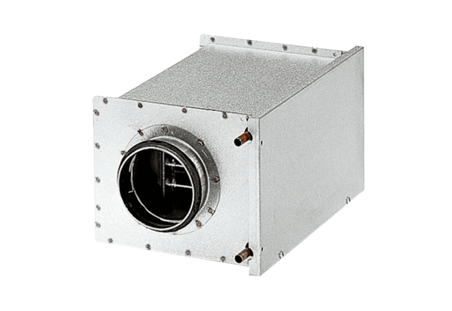Water air heater WRH 16-2Packing unit: 1 pieceRange: C
Article number: 0082.0118Manufacturer: MAICO

