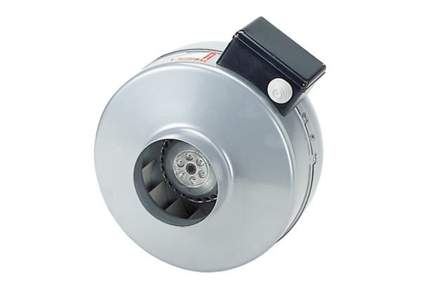Centrifugal duct fan ERR 16/1 NPacking unit: 1 pieceRange: E
Article number: 0080.0867Manufacturer: MAICO

