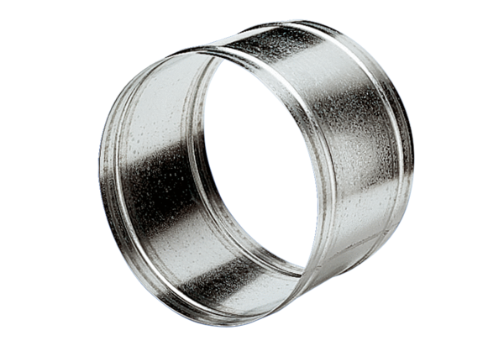Extension sleeve VH 50Packing unit: 1 pieceRange: C
Article number: 0055.0035Manufacturer: MAICO

