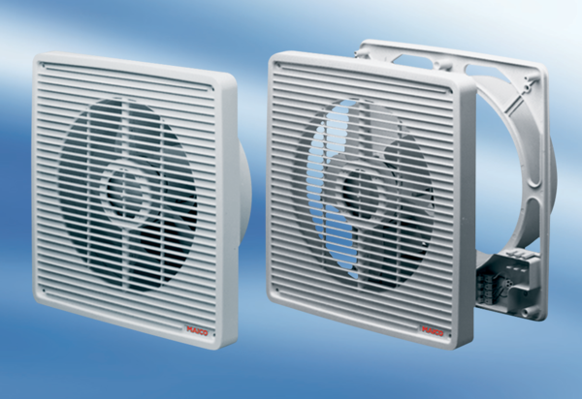Wall-mounted fan EN 20Packing unit: 1 pieceRange: C
Article number: 0081.0301Manufacturer: MAICO

