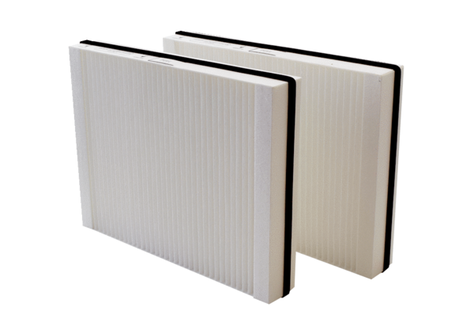Air filter, replacement WSG 300Packing unit: 2 piecesRange: K
Article number: 0093.1325Manufacturer: MAICO

