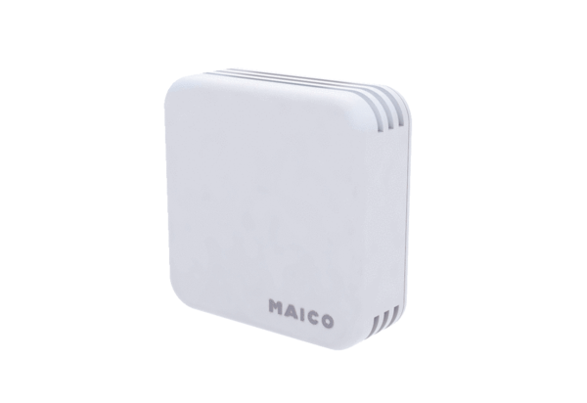Air quality controller EAQ 10/2Packing unit: 1 pieceRange: C
Article number: 0157.0834Manufacturer: MAICO

