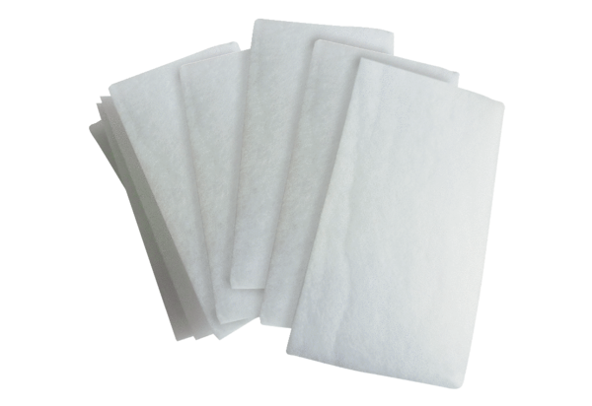Air filter, replacement WSG 170Packing unit: 10 piecesRange: K
Article number: 0093.0270Manufacturer: MAICO

