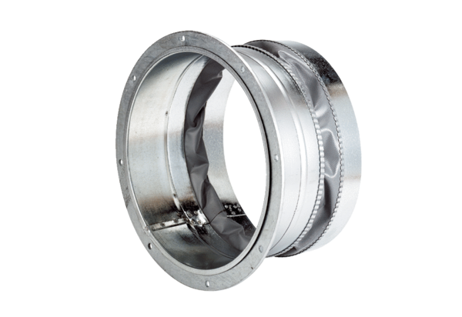Flexible coupling ELA 50Packing unit: 1 pieceRange: C
Article number: 0092.0271Manufacturer: MAICO

