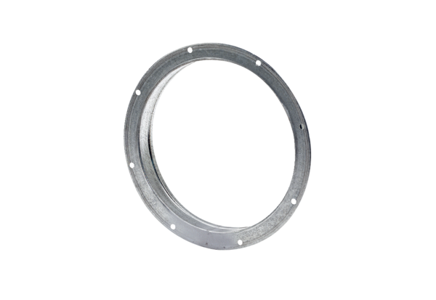Counter socket GS 25Packing unit: 1 pieceRange: C
Article number: 0055.0169Manufacturer: MAICO

