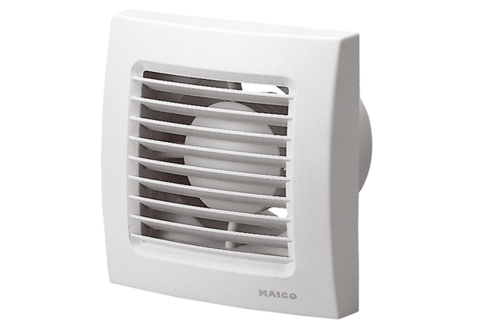Small room fan ECA 120 PPacking unit: 1 pieceRange: A
Article number: 0084.0034Manufacturer: MAICO

