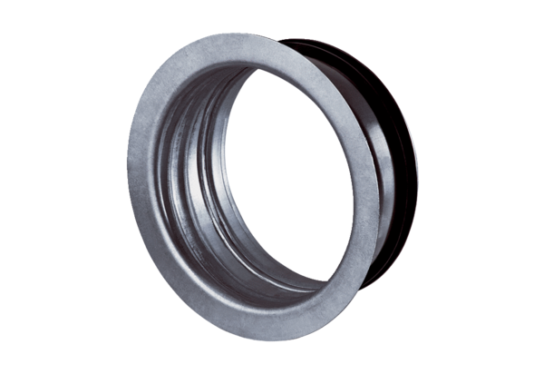Mounting frame for TFA/TFZ EBR-D 12Packing unit: 1 pieceRange: C
Article number: 0092.0494Manufacturer: MAICO

