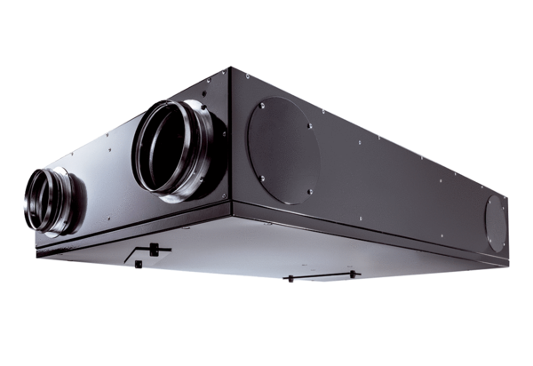Centralised ventilation unit Trio LZPacking unit: 1 pieceRange: K
Article number: 0095.0124Manufacturer: MAICO

