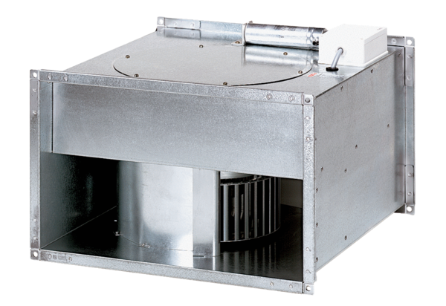Channel fan EPK 22/4 BPacking unit: 1 pieceRange: D
Article number: 0086.0651Manufacturer: MAICO

