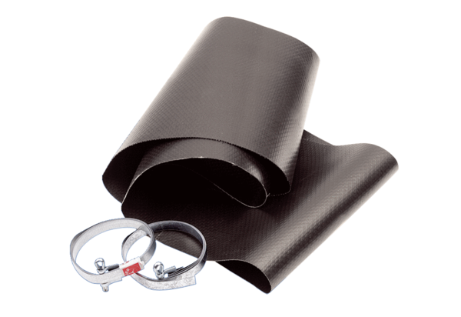Flexible cuff EL 30Packing unit: 1 pieceRange: C
Article number: 0092.0089Manufacturer: MAICO

