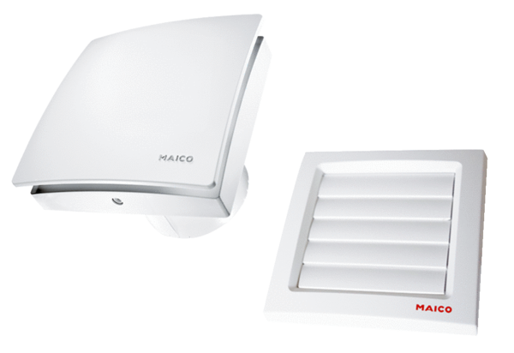Small room fan AKE 100Packing unit: 1 pieceRange: A
Article number: 0084.0220Manufacturer: MAICO

