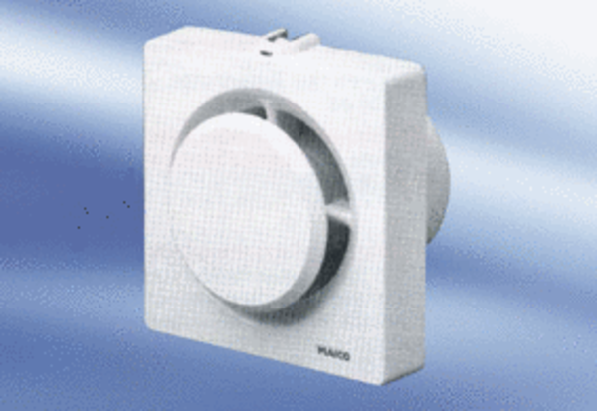Small room fan ECA 11-1 VZPacking unit: 1 pieceRange:
Article number: 0080.0503Manufacturer: MAICO

