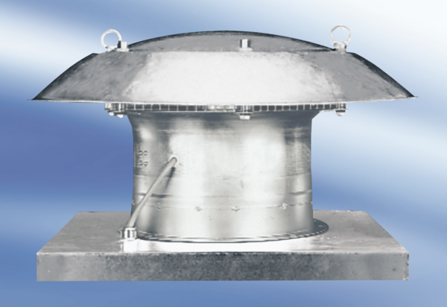Axial roof fan DZD 30/84 APacking unit: 1 pieceRange:
Article number: 0087.0434Manufacturer: MAICO

