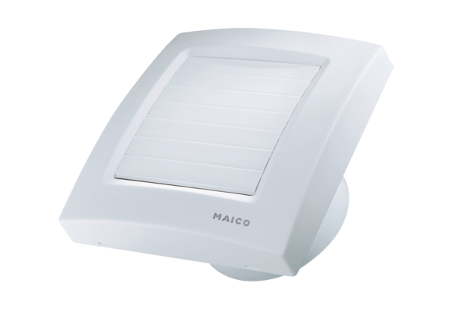Small room fan ECA 100 KPacking unit: 1 pieceRange: A
Article number: 0084.0003Manufacturer: MAICO

