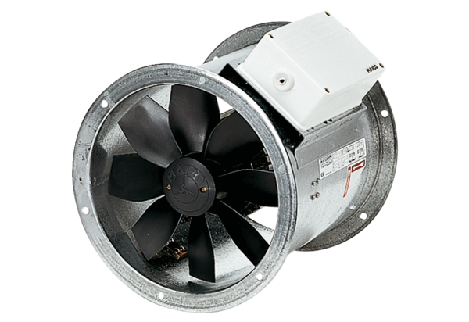Axial duct fan EZR 40/6 BPacking unit: 1 pieceRange: C
Article number: 0086.0008Manufacturer: MAICO

