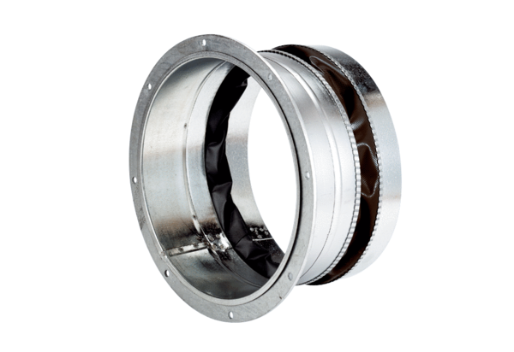Flexible coupling ELA 35 ExPacking unit: 1 pieceRange: C
Article number: 0092.0277Manufacturer: MAICO

