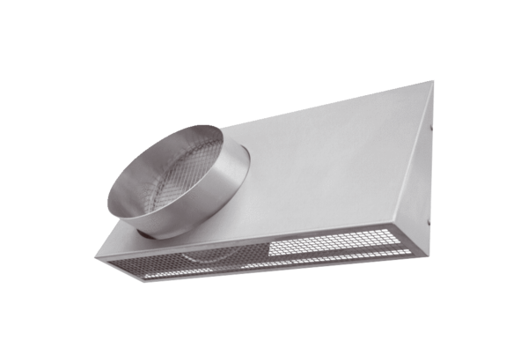Combi-wall connections KWH 16 RPacking unit: 1 pieceRange: K
Article number: 0152.0060Manufacturer: MAICO

