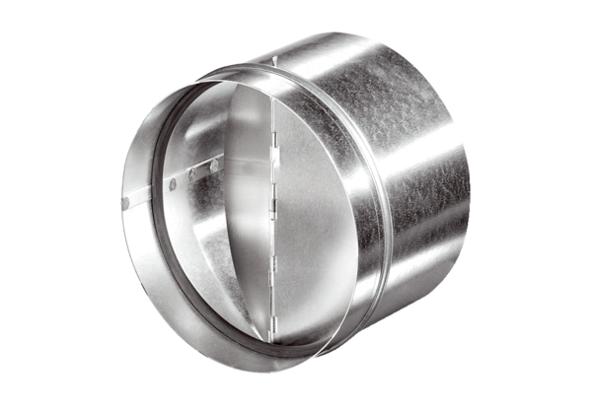Automatic backflow preventer AVM 28Packing unit: 1 pieceRange: C
Article number: 0093.0011Manufacturer: MAICO

