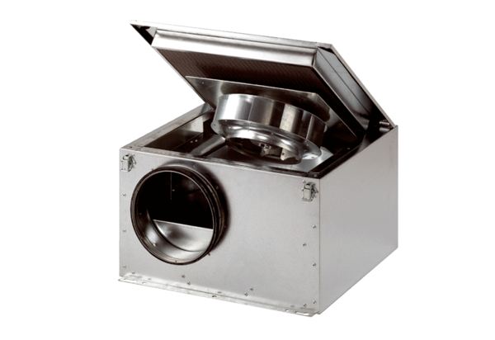Sound-insulated ventilation box DSR 40 SPacking unit: 1 pieceRange: C
Article number: 0080.0233Manufacturer: MAICO

