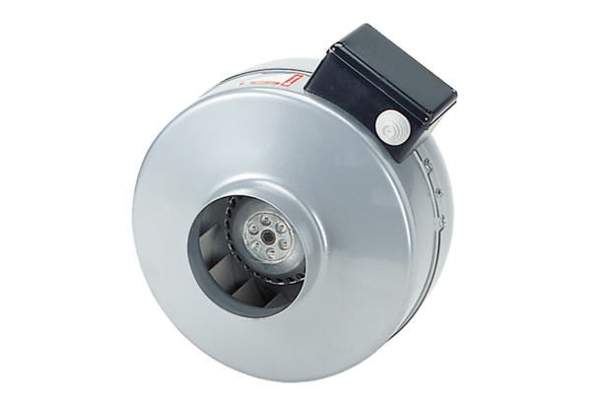Centrifugal duct fan ERR 16/1 SPacking unit: 1 pieceRange: C
Article number: 0080.0274Manufacturer: MAICO

