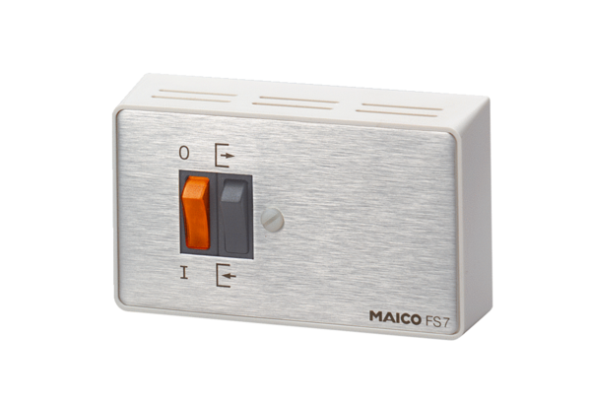Reversing switch FS 7Packing unit: 1 pieceRange: C
Article number: 0016.0107Manufacturer: MAICO

