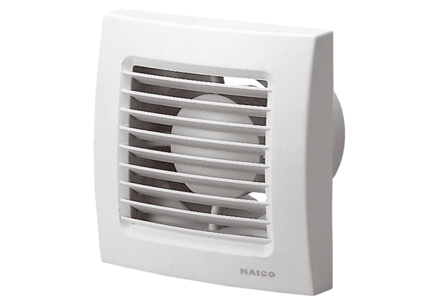Small room fan ECA 100Packing unit: 1 pieceRange: A
Article number: 0084.0000Manufacturer: MAICO

