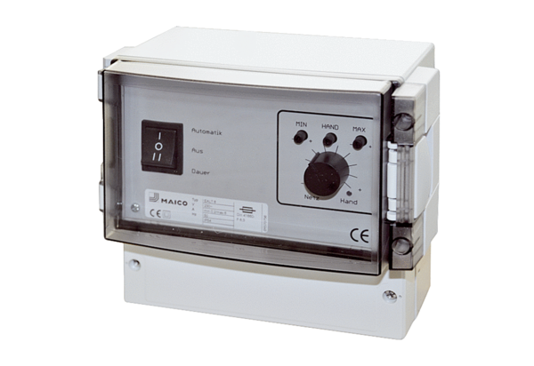Temperature control system, power module EALT 6Packing unit: 1 pieceRange: C
Article number: 0157.0756Manufacturer: MAICO

