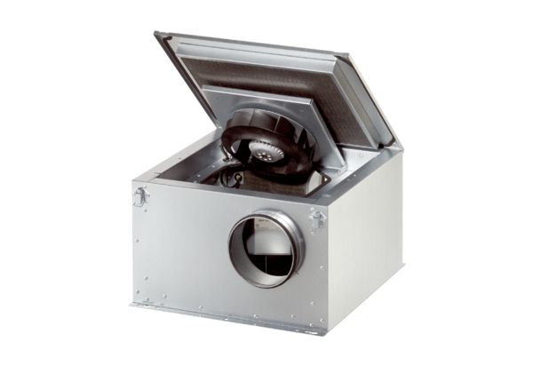Sound-insulated ventilation box ESR 25-2 ECPacking unit: 1 pieceRange: E
Article number: 0080.0713Manufacturer: MAICO

