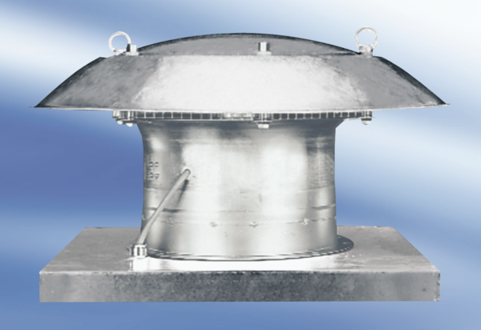Axial roof fan DZD 40/42 APacking unit: 1 pieceRange:
Article number: 0087.0446Manufacturer: MAICO

