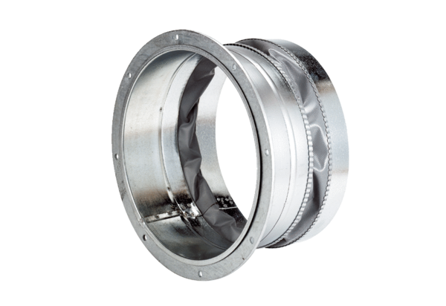Flexible coupling ELA 31Packing unit: 1 pieceRange: C
Article number: 0092.0284Manufacturer: MAICO

