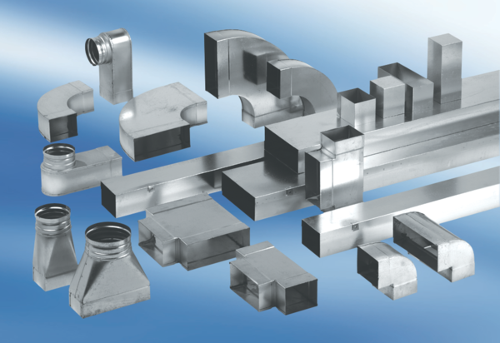40 mm channel sound absorbers with lining and attenuating linging KSDA55/220/1200Packing unit: 1 pieceRange: K
Article number: 0092.0471Manufacturer: MAICO

