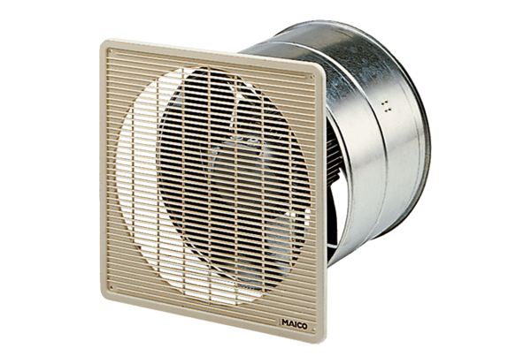EZF 35/6 BPacking unit: 1 pieceRange: C
Article number: 0085.0055Manufacturer: MAICO

