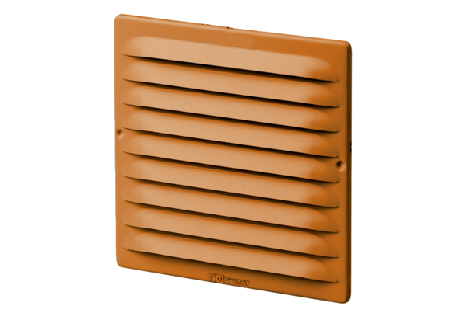External grille MGE 80/125 cuPacking unit: 1 pieceRange: K
Article number: 0078.0032Manufacturer: MAICO

