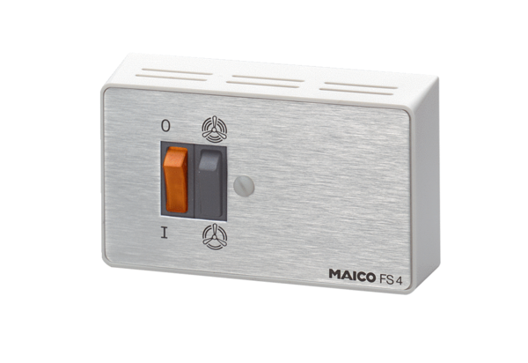Step switch FS 4Packing unit: 1 pieceRange: C
Article number: 0016.0104Manufacturer: MAICO

