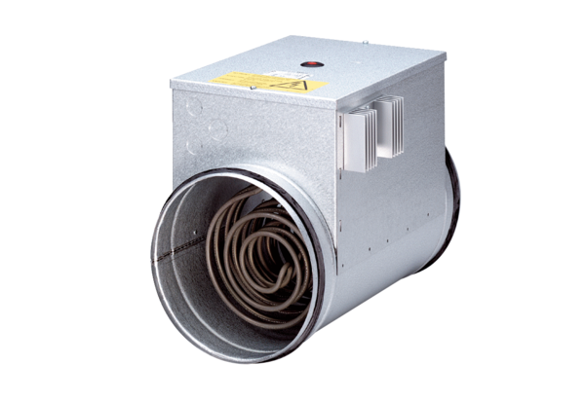Electrical air heater with controller DRH 40-12 RPacking unit: 1 pieceRange: C
Article number: 0082.0148Manufacturer: MAICO

