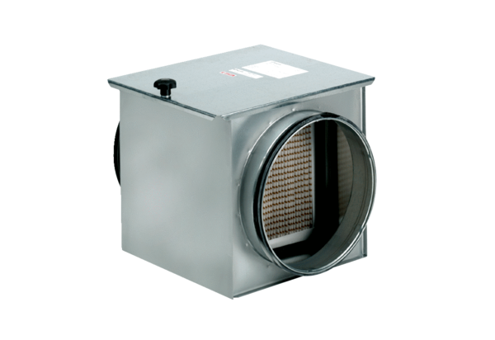Air filter TFE 35-7Packing unit: 1 pieceRange: C
Article number: 0149.0056Manufacturer: MAICO

