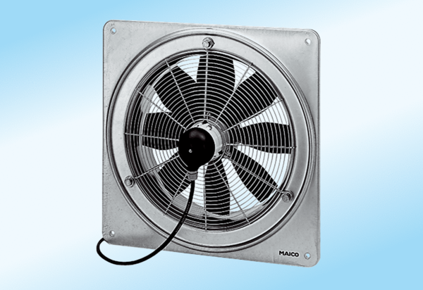Axial wall fan DZQ 20/4 A-ExPacking unit: 1 pieceRange: C
Article number: 0083.0755Manufacturer: MAICO

