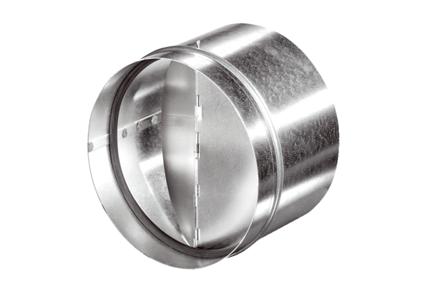Automatic backflow preventer AVM 20Packing unit: 1 pieceRange: C
Article number: 0093.0006Manufacturer: MAICO

