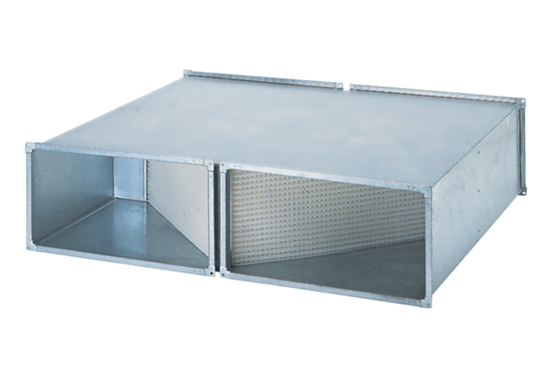Heat exchanger WT 1500Packing unit: 1 pieceRange: D
Article number: 0152.0042Manufacturer: MAICO

