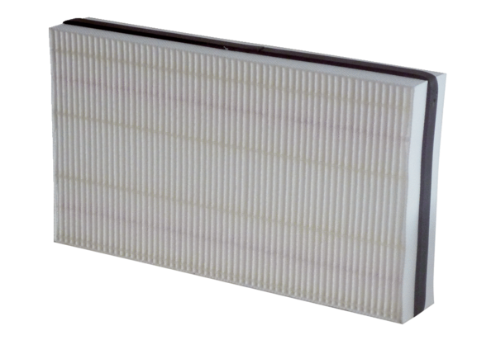Air filter, replacement WSF 300Packing unit: 1 pieceRange: K
Article number: 0093.1324Manufacturer: MAICO

