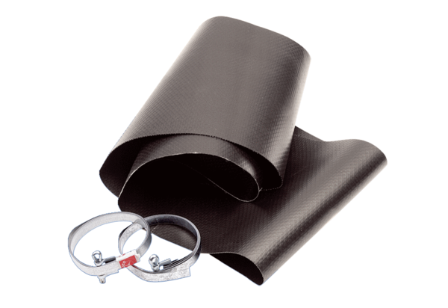Flexible cuff EL 60Packing unit: 1 pieceRange: C
Article number: 0092.0093Manufacturer: MAICO

