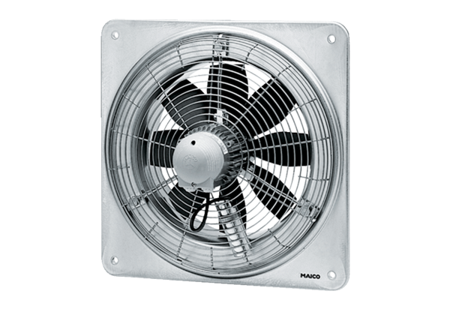Axial wall fan DZQ 35/2 BPacking unit: 1 pieceRange: C
Article number: 0083.0060Manufacturer: MAICO

