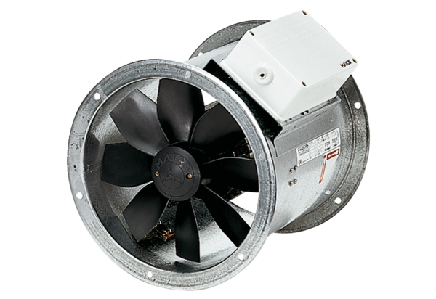Axial duct fan DZR 30/42 BPacking unit: 1 pieceRange: C
Article number: 0086.0044Manufacturer: MAICO

