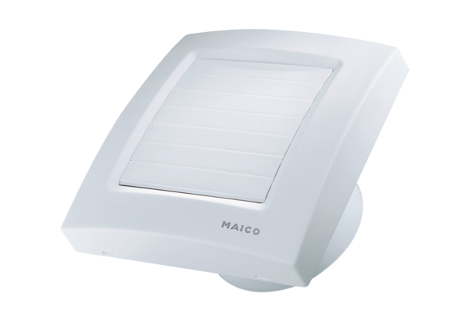Small room fan ECA 100 KVZPacking unit: 1 pieceRange: A
Article number: 0084.0004Manufacturer: MAICO

