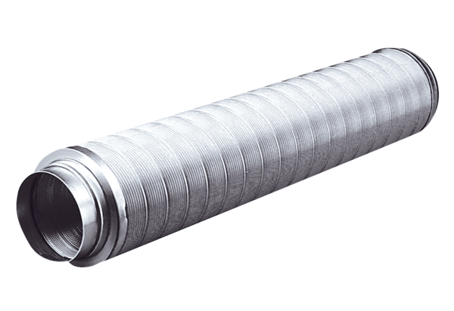Tubular sound absorber RSR 10Packing unit: 1 pieceRange: C
Article number: 0092.0311Manufacturer: MAICO

