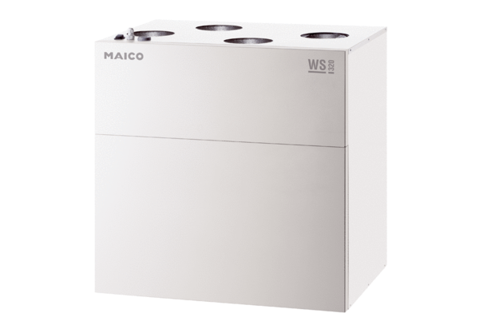Centralised ventilation unit WS 320 BETPacking unit: 1 pieceRange: K
Article number: 0095.0225Manufacturer: MAICO

