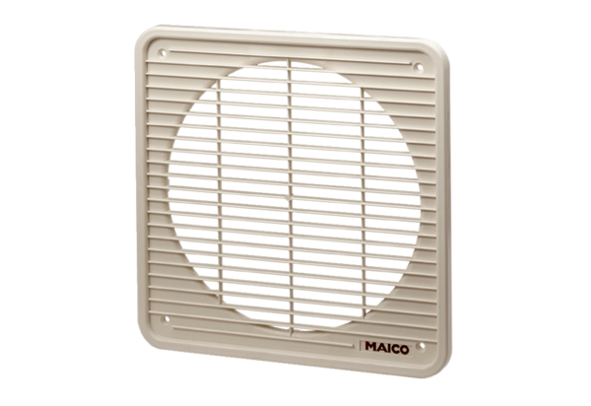Internal grille IG 35Packing unit: 1 pieceRange: C
Article number: 0059.0174Manufacturer: MAICO

