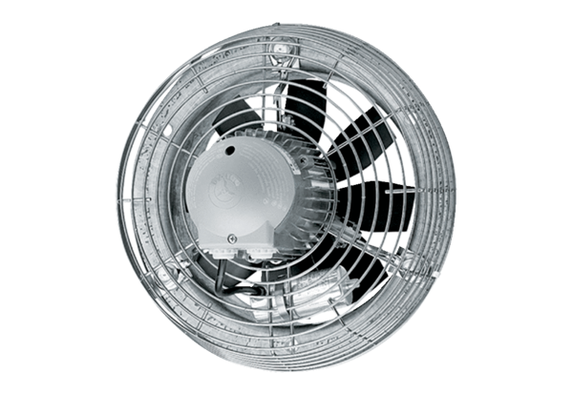Axial wall fan DZS 60/8 BPacking unit: 1 pieceRange: C
Article number: 0094.0063Manufacturer: MAICO

