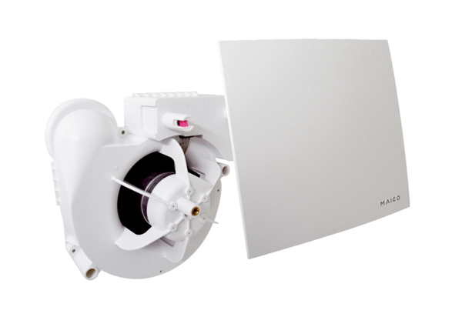Fan insert ER 60 EPacking unit: 1 pieceRange:
Article number: 0084.0371Manufacturer: MAICO

