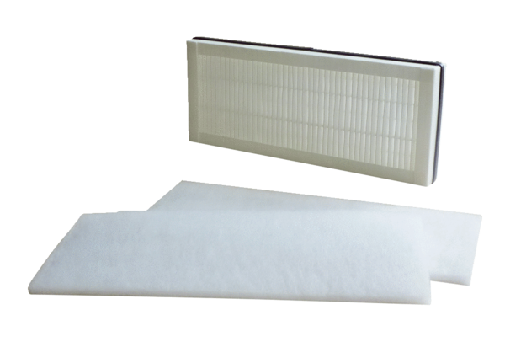Air filter, replacement WSF 300-400Packing unit: 1 set (3 pieces)Range: K
Article number: 0093.0898Manufacturer: MAICO

